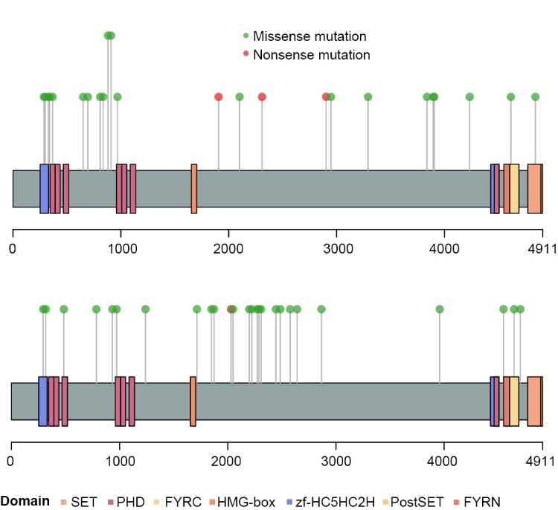
Supplementary Fig. 1. Lollipop plot illustrating the KMT2C mutation in MM samples in the DFCI2015 (top) and DFCI2019 (bottom) cohort across the KMT2C protein domains.

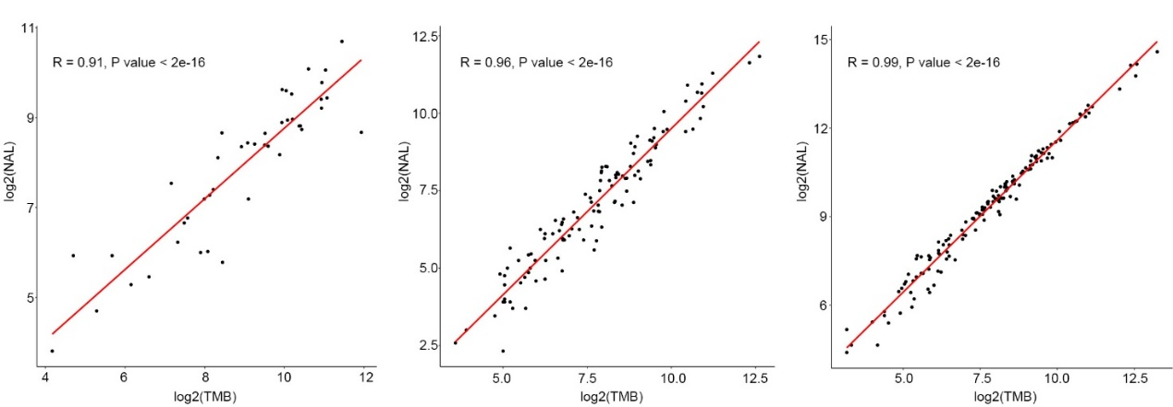
Supplementary Fig.2. Dot plot illustrating the positive correlation between TMB and NAL level in TCGA-SKCM (left), DFCI2015 (middle) and DFCI2019 (right) cohort.

